Binary Search

Understand Binary Search
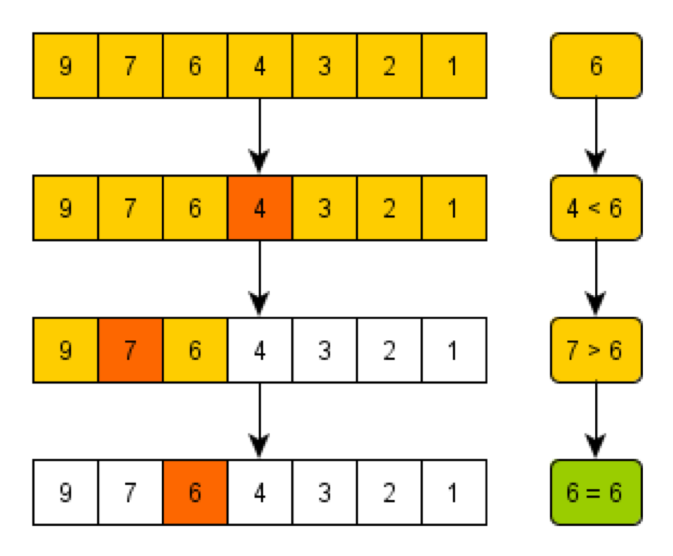

Problem: To find if n is a square of an integer
if(mid*mid==x):
return mid
else if (mid*mid>x):
binary_search(left,mid-1)
else:
binary_search(mid+1,right)

Other Problems to try:
Find the frequency of a given target value in an array of integers

Find the peak of an array that increases and then decreases

A sorted array is rotated n times. Search for a target value in the array.

